Grove Academy

Relationship Policy

October 2023

Draft

**Rationale**

Building positive relationships is critical to ensuring high quality learning and teaching takes place. Classroom teachers should encourage, inspire and motivate learners. In Grove Academy, we believe that Classroom Teachers should enable learners to take ownership of their learning and behaviour in their classroom and make all efforts to support learners to maximise their learning and deal with challenging behaviours in a restorative way. The purpose of this policy is to clearly set out the role of the Classroom Teacher and others in promoting positive relationships and how incidents should be dealt with in a consistent and restorative way by the most appropriate member of staff.

**Restorative Approaches**

The aim of restorative approaches is to help learners to build and maintain positive, healthy relationships, resolve difficulties and repair harm where there has been conflict. This approach can help address the underlying reason for a learner's behaviour. Learners are encouraged to learn from their choices and mistakes and take ownership of their own behaviour. By adopting this approach learners will learn how to resolve disagreements, empathise with others, show forgiveness and communicate more effectively. It will also enable learners to develop critical social and emotional skills, such as communication, empathy, and problem-solving. These skills are essential for academic success and can help learners in all areas of their lives.

**Positive Relationships**

At Grove Academy we believe that positive relationships are fundamental to enable effective teaching and learning to take place. Through implementation of this relational approach we aim to build on our school values of **Honesty, Respect, Responsibility, Fairness** and **Determination** to create a caring, supportive, learning environment that:-

* values and promotes positive, restorative and respectful relationships
* is inclusive and safe
* supports learners and develops their skills and resilience enabling them to become responsible for their own behaviour
* recognises that all behaviour is communication
* Aims to understand what is being communicated in order to identify and assess the underlying needs to work with learners find solutions.

The guiding principles of nurture, founded on sound psychological research, help us to take a holistic approach to the learner. This holistic approach to wellbeing also underpins Getting It Right For Every Child (GIRFEC). Nurture, when thoroughly understood and implemented leads to greater academic attainment; improved behaviour and attendance; reduced exclusions; greater attachment to staff, school and community; long term mental health improvements and improved resilience. Curriculum for Excellence also promotes health and wellbeing as a responsibility of all to ensure that achieving good affective outcomes for all learners is seen as a priority.

**Relational, restorative approaches versus traditional approaches**

Every learner has the right to a high-quality education.

However, even in these conditions, some learners will present with behaviour that challenges or is difficult to interpret. We understand that everyone learns best when they feel good about themselves. Punitive approaches are often not enough to deter learners from misbehaviour. This type of response can be ineffective, dangerous, breed resentment and make situations worse as the learner can be resentful of punishment rather than reflective of their actions. Learners require the opportunity to hear about and face up to the harm and distress they have caused others and how they can put it right.

Positive approaches to support behaviour focusses on relationships, skills building, restoration and when appropriate logical or natural consequences appropriate to the learner, rather than the implementation of punishments. In this Relationship Policy all staff will focus on positive relationships by looking for opportunities to encourage learner skills, recognise effort and build on strengths. The school uses approaches and strategies which are designed to help prevent and de-escalate difficult situations and identify and support individual support needs. Support and training with de-escalation will be ongoing.

**Key drivers linked to our Relationships Policy and Procedures:**

* **GIRFEC**
* **Respect Me Guidelines**

At Grove Academy we aim to provide a positive learning environment with pupils given the opportunity to engage in learning without the harm and distress caused by bullying behaviour. Please see our Anti Bullying policy for further details

<http://respectme.org.uk/>

* **Rights Respecting Schools Award (RRSA)**

Staff and pupils have worked across the whole school to gain Bronze level RRSA.

<https://www.unicef.org.uk/rights-respecting-schools/>

<https://education.gov.scot/parentzone/my-child/what-is-my-child-entitled-to/Children's%20rights>

**Roles & Responsibilities**

**Parents and Carers**

Parents and carers are key partners who are asked to work in partnership with the school. They are expected to assist in maintaining positive relationships and support restorative approaches and high expectations for positive behaviour. Parents/carers are invited to raise with the school any issues arising from the operation of the policy. Parents/ carers will be made aware of any concerns via email in the first instance. See Appendix 8. Consultation with parents/ carers about the implementation and effectiveness of our draft relationship Policy will take place in upcoming months.

**Learners**

Learners participate in supporting this procedure and contribute to our positive school ethos. All learners know our school values and expectations. Learners are supported to ensure that incidents of disruption, violence, bullying and any form of harassment are reported. The implementation of this procedure allows learners to understand the cause and effect of their behaviour. See Appendix 9. Consultation with Learners about the implementation and effectiveness of our draft relationship Policy will take place in upcoming months.

**Staff**

Every member of staff in Grove Academy is responsible ensuring that the policy and procedures are followed and has a role in building and sustaining positive relationships. We set high expectations, model positive behaviour and deal with situations in a calm and consistent manner. In Grove Academy positive behaviour is achieved in two ways:

**1. Proactive**– Preventative promoting positive behaviour strategies which encourage each Learner to develop a sense of responsibility and self-control. Our Teacher Grove Standard for Learning and Teaching (GSLT) sets out our expectations. Good organisation, lesson planning and preparation will help to create the right learning environment. Flexibility, choice and, where appropriate, differentiation will also help to support individual needs and promote positive relationships and behaviour.

**2. Responsive**– When negative behaviour occurs we respond positively and effectively.

In these instances, there are clear guidelines in place to inform appropriate next steps to address concerns. The Grove Pupil and Teacher Standard for Learning and Teaching (GSLT), created by our staff and pupils respectively, clearly sets out the expectations of both teachers and pupils. See Appendix 6 & 7 for copies of the Teacher and Learner Flowchart, Appendix 3- 5 Teacher, PT and House Team Toolkits which details examples of the strategies staff may use.

Pupils who are not meeting our expectations will be encouraged to take responsibility for their behaviour and the impact this is having on both their own and others learning. They will be supported by staff to re-engage with their learning. This is detailed in the Learner Flowchart which will be displayed in classrooms.

Principal Teachers may note a record of phone calls to parents/carers in Pastoral Notes and alert House Teams. (see Appendix 12 for details of ethical recording, Appendix 13 for instructions for recording on pastoral notes).

Wellbeing concerns will continue to be recorded through the referral process and passed to PTs for information/ action then passed to PT Guidance. PT Guidance will then action as appropriate and then pass to House Heads for information.

**Restorative Conversation**

A restorative approach may include having a 'restorative conversation'. These conversations may happen during the school day and staff will use restorative language and questions to allow children and young people to understand the impact of their behaviours. The structure of the restorative conversation is very important. A school-wide consistent approach ensures that everyone, both staff and learners have the same opportunity to experience a meeting that feels safe enough to allow them to discuss what happened, to explore the impact on those involved, to talk through any unmet needs and to come up with a plan to prevent a reoccurrence. There will opportunities for this to explored in more detail throughout the year. Examples of restorative questions can be seen in Appendix 10 .

Appendix 1 **Teacher GSLT**

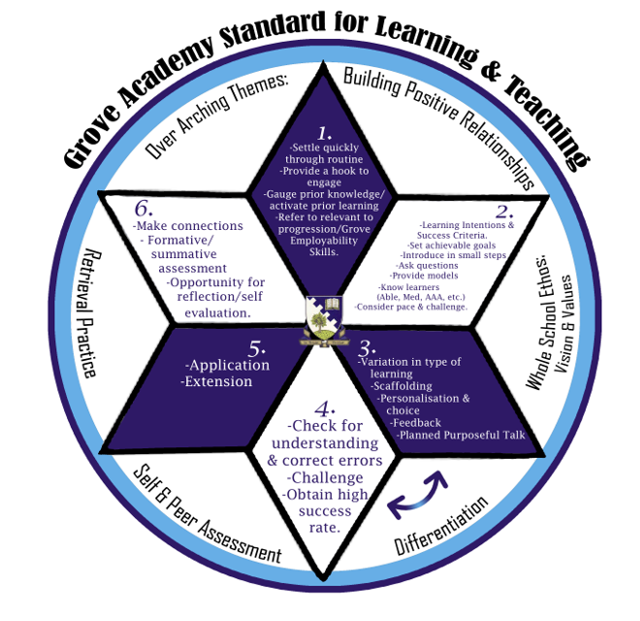Appendix 2 **Pupil GSLT**

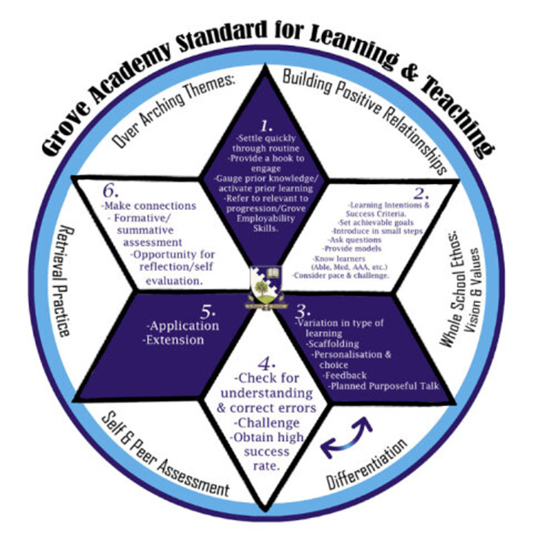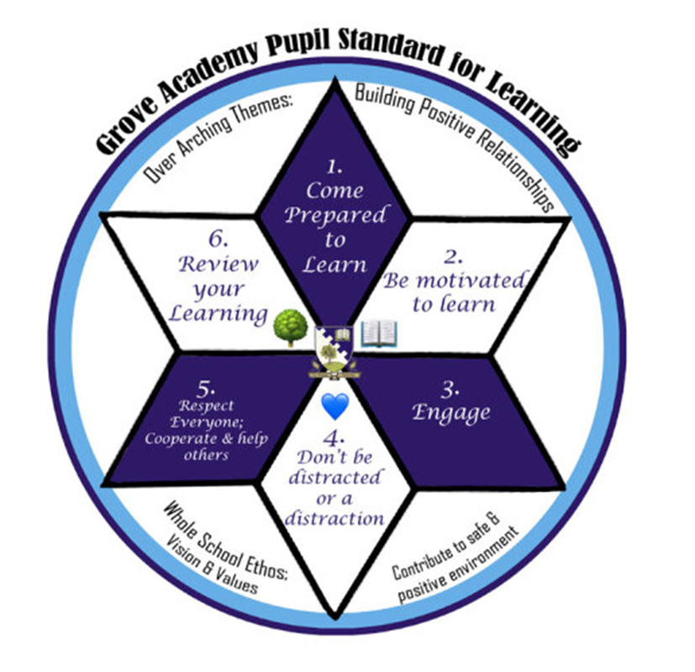

Appendix 3 **Teacher Toolkit**

**Proactive**

**Before/ after the class**

* know learners – read daily pupil bulletin, Confidential information, ABLe plans, speak to PTG/SFL, colleagues
* create a positive climate for learning
* Tracking and monitoring to analyse patterns and put in place appropriate supports
* Be organised for lesson and keep the classroom tidy and organised
* Use of ABLe website to identify further strategies for use at a Universal level in classroom [ABLe Main | ABLe Drupal site (ableschools.org.uk)](http://www.ableschools.org.uk/able-main) – mind maps and PDFs on many topics including- attention, memory, behaviour management

**In the classroom**

Model positive relational approach

* New day, new chance
* Meet & greet learners at door using learner names
* Consistent approach in class
* Use restorative language
* Starter on board if relevant
* Remind Learners of school values of Honesty, respect, responsibility, fairness and determination and how these are embedded through GSLT
* Have clear and consistent expectations of learning and behaviour by promoting Grove Standard for Learning and Teaching (GSLT)
* Explain to learners any additional expectations in class relating specifically to your subject and revisit these regularly
* Praise the positive first- actively seek out opportunities to praise learners for making positive choices and action
* visible Instructions
* scaffold instructions as needed

**Responsive**

* Draw attention to positive behaviour
* Reminder of GSLT
* Reminder of task/ breakdown into chunks
* Check understanding of task
* Change of learning task / differentiate task
* Apply strategies previously identified from ABLe
* Change of seating / grouping.
* Provide a temporary ‘cool down’ from class (in general, three minutes should be enough).
* Learner given time out from class from class to reflect on why they are not following GSLT expectations. Think card offered? After 2 mins, CT has a restorative chat in the corridor with learner. If resolved then learner welcomed back into classroom
* Refer to PT for support
* Help and encourage learners to restore and repair relationships
* Restorative conversation

**Proactive and Responsive**

* Remind learners mistakes are ok- here to learn
* Reflection of classroom practice - learning and teaching methodologies used.
* Access collegiate support – advice / peer observation / feedback.
* Liaise with Guidance teacher /SFL
* Change of seating/ grouping/learning task
* Remain calm and consistent with reminders of GSLT
* Try to make time to discuss with the learner possible reasons for behaviour
* Strategies discussed at Faculty Meetings
* Differentiation strategies employed
* Positive messages/ rewards to motivate

Appendix 4 **PT Toolkit (as per Class Teacher)**

* Departmental target sheet monitored by PT
* Contact parent/carer to discuss concerns
* Extracted within the department – but with the learner still learning. This should last for an agreed period of time and the learner should be made aware of this timeframe. Achievable but challenging work should be set. The learner should report to the subject PT (not the class teacher) at the beginning of the lesson, who will issue work and register the learner.
* Issue a “pay time back”. The PT Subject would contact parent/ carer to arrange and would record conversation in pastoral notes alerting PTG/ House Head. Learners should be supervised and in order to have maximum effect this time is best used by having a restorative worksheet completed by the learner to try to re-connect the learner to their learning. Good use of this time may also include the supported completion of missed work/homework specific to the subject.
* Facilitate a restorative conversation with the learner and class teacher

Appendix 5 **House Team Toolkit (PT Guidance, House Head, Link SFL Teacher)**

**House Teams**

* Pass on relevant information to CT (including information from Primary School)
* Monitor attendance and support learner to engage with learning
* Refer to Attendance Management Group
* target sheet monitored by PTG or House Head
* PTG to work with learner and look for strategies for support in class using Wellbeing Wheel, Glasgow Tool, Resilience Matrix and share with CT
* Discuss at House Team Meeting
* Request further assessment or advice from SFL department
* Contact parent/carer to discuss concerns
* Facilitate a restorative conversation with the learner and class teacher if needed
* Arrange TATC
* Produce and share ABLe plan to provide strategies for CT
* Referral to SRT for targeted support
* Liaise with partners to support learner
* Consider adaptations to timetable
* Referral to Grove Integrated Support Team (GIST) for specialist support/ partners out with education
* Use information from CT in reports to discuss most suitable pathways at course choice with learners and parents/carers
* Liaise with Skills Development Scotland and Youth Employability Service to ensure positive destination

Appendix 6 **Learner Flowchart**

Appendix 7 **Teacher Flowchart**

Appendix 8  **Expectations of Parents/ Carers**

Appendix 8 **Expectations of Learners**

**Parents should**

* Encourage learner to attend school regularly and on time.
* Ask learner about how their day has been
* Contact Guidance Teacher if there is anything out of school that could be impacting on pupil’s learning
* Check emails regularly to see if any have been sent by school staff
* Support learner to engage with homework and revision
* Help develop their child’s learning at home and in the community.
* Work in partnership with the school to ensure that learners get the most out of their school and their education.
* Express their views in an appropriate way and at an appropriate time on matters affecting the education of their learner.

**Learners should**

* Be on time for school and classes
* Keep all mobile devices off and out of sight unless given permission by the class teacher to use it
* Follow the class expectations as detailed in Grove Standard for Learning and Teaching
  + 1. Come prepared to learn
  + 2. Be motivated to learn
  + 3. Engage
  + 4. Don’t be a distraction or a distraction
  + 5. Respect Everyone; Cooperate and help others
  + 6. Review their learning
* Speak to their class teacher and or Guidance Teacher if there is an issue and work with them to look at ways to make things better
* Ask teacher if possible to have timeout of classroom if getting stressed (this should be agreed ahead of time if possible)

Appendix 10 **Restorative Questions**

**1. What happened?**

• It is important to listen attentively to the young person’s account of what happened without interrupting or disagreeing

• It is equally as important that the teacher has the opportunity to offer the young person their perspective

• Language is important here – avoid being judgemental when listening to the young person’s account, eg. ‘and then *you* decided to throw the pen.’ This keeps the focus of the conversation away from being punitive, authoritarian or blaming and instead ensures that dialogue is restorative and collaborative with a focus on the future.

**2. What were you thinking at the time and what have you thought since?**

• Following a period of reflection, it is important that a young person is given the opportunity to discuss their actions and thought process when the incident took place

• In giving a young person the opportunity to explain their thoughts since the incident, we provide them with an important off-ramp – an opportunity for the young person to explain their actions after a period of reflection, to offer an apology or to explain a change in attitude going forward.

**3. Who has been affected and how did this make them feel?**

• It is important that the young person has the opportunity to consider others

• The young person may need some gentle encouragement to recognise that there may be a number of people who have been affected by their actions

• By asking how others may have been impacted by this incident, we are encouraging the young person to reflect on their actions and to use their conscience

• Ask the young person to list the people who have been impacted by their actions and to consider how they have been affected. This is important as in a moment of crisis, this is often irrelevant and the young person may be oblivious to the impact of their actions on others.

**4. What should we do to put things right?**

• It is important that we do not demand an apology from the young person – a forced apology is worthless. Furthermore, there may be other ways to put things right.

• It may take time for the young person to reach the point where they are able to offer an apology and when it is offered, it may not be as sincere as you would like. In such instances, try to accept their apology with enthusiasm.

**5. How can we do things differently in the future?**

• It is likely that the young person will meet similar situations and frustrations in future. The key here is to help the young person recognise when their behaviour pattern begins and to consider what, with our support, they can do in order to prevent escalation and avoid them making further poor choices.

Appendix 11 **Teacher Instructions for use of Messenger 7**

Appendix 12 **Seemis Instructions for Writing Pastoral Notes (see separate PDF for instructions)**

PTs should use this for recording details of interventions such as records of phone calls or emails sent home (emails should be copied onto a pastoral note from both PTs and parents/carers). See pg 1-5 of following instructions.

Staff should ensure all notes are written factually, without any emotive language unless direct quotes and if referencing another pupil, they should use initials rather than full names.

Detila on how to access pastoral notes follows. Staff should also ensure once they have written a pastoral note they should alert the relevant PTG and House Head (p6 of instructions).

It is also possible to add an alert to several pupils at once if needed. This may be useful if a positive postcard etc has been sent home- see Page 7& 8

Pupil Profile is where you can find details of attendance, referrals and copies of previous reports all of which may be useful – pg11

Pg12-14 is not for our use and is for the office to set up accounts.

Appendix 13 **Instructions for Pts for entry in Pastoral Notes**