

[](http://www.google.co.uk/imgres?q=customer+service&um=1&hl=en&tbo=d&rlz=1R2ADRA_enGB516&biw=1920&bih=924&tbm=isch&tbnid=m1w8D3MZ5cIwiM:&imgrefurl=http://www.amideast.org/node/3394&docid=JcdSV5cKa6eKPM&imgurl=http://www.amideast.org/sites/default/files/customer_service_pic.jpg&w=315&h=212&ei=g_YMUeagHYOI0AXt_oCADA&zoom=1&ved=1t:3588,r:25,s:0,i:228&iact=rc&dur=1124&sig=100532141430501027914&page=1&tbnh=165&tbnw=252&start=0&ndsp=33&tx=184&ty=39)

S3 Business Enterprise & ICT

Unit 3

Administration & IT

Introduction to Unit

The main focus of this unit is to explore the important role of administration within a business including aspects of customer care and health and safety.

The Unit is split into 3 sections:

* **Tasks, Skills and Qualities of an Administrator**
* **Customer Care**
* **Health & Safety in the Workplace**

After working through this unit you will be able to:

* Explain the duties of the Administration Department
* Identify the skills and qualities of an Admin Assistant
* Explain the purpose of a job description and person specification
* Create a job description and person specification
* Summarise the use of application forms and CV’s
* Interpret a Job Advert
* Apply knowledge and skills to create a detailed job description and person specification, with a partner
* Benefits of good customer service
* Consequences of bad customer service
* Explain the responsibilities of employers and employers under the Health & Safety at Work Act (1974)
* Distinguish between hazards and faults and suggest ways of making them safe
* Explain the purpose of an Accident Report Form
* Give examples of ways an organisation ensures the security of staff, equipment and information

**ADMINISTRATION DEPARTMENT**

This department looks after a number of ***‘support services’***which include:



**✓ THE MAIL ROOM**

In many businesses, all the mail is delivered by the post office first thing in the morning to a centralised mail room. Here it is sorted by the mail room staff and then distributed to the different departments of the business. The mail room will also distribute centrally received e-mails.

Many new office staff work in the mail room when they are first appointed, which gives them an opportunity to get to know their way around a large business and to find out who works where.

**✓ THE REPROGRAPHICS DEPARTMENT**



The Reprographics Department is responsible for making sure that copies of documents, letters, books, leaflets, posters and adverts required are produced.

The main piece of office equipment used here is the photocopier. This area is usually centralised.

**✓ THE FILING DEPARTMENT**

In many businesses, one department is responsible for the sorting and filing of all the papers in the firm which may be required for future reference.

Centralised filing saves space, ensures a uniform method of filing and makes better use of both filing staff and equipment, however papers may be out when required, and the filing department may be some distance from many of the offices thereby causing a waste of time when staff go to borrow files.

**✓ THE RECEPTION**

 The Reception area of any business should provide a good first impression to visitors when they call.

The Receptionist gives visitors the first impression of a business and it is therefore vital he/she is polite, friendly, smart and helpful.

Most visitors to a business will hand over a **Business Card** to the Receptionist and sign a visitor’s book before being directed to the member of staff they have come to see.

**TASKS, SKILLS AND QUALITIES OF AN ADMINISTRATOR**

The Administration Department provides **SUPPORT** to employees and other departments within the organisation.

They do this by:

* Preparing Word documents including memos, business letters and reports
* Arranging business travel
* Managing the Reception Area, including telephone calls
* Reprographics
* Filing of documents
* Handling Mail (paper and electronic) - both incoming and outgoing

**QUALITIES** and **SKILLS** of an Administration Assistant

|  |  |
| --- | --- |
| **QUALITIES** | **SKILLS** |
| * Patience | * ICT – MS Office |
| * Tact | * Team working |
| * Polite | * Organisation |
| * Friendly | * Use own initiative |
| * Confident | * Communication |
| * Enthusiastic | * Time management |
| * Well groomed | * Literacy |
|  | * Numeracy |



**JOB DESCRIPTION**

The job description clearly describes the nature of the job and what it involves.

It contains the following information:

* The job title
* The main duties of the job
* Who the employee will be reporting to
* Who the employee will be responsible for
* The employee’s salary
* The employee’s holiday entitlements
* How to apply for the job

**PERSON SPECIFICATION**

The person specification clearly describes the type of person the organisation believes will best suit the job.

The Person Specification contains the following information:

* The skills required
* The personal qualities required
* The qualifications required
* The experience required

Each of these is usually classed as **ESSENTIAL** (the candidate must have the skill, quality, qualification or experience) or **DESIRABLE** (would be an advantage, but is not necessary).

***For example***, excellent ICT skills will be **ESSENTIAL** for an admin assistant whereas previous experience of working in an office environment could be **DESIRABLE.**

**ACTIVITY 1**

Creating a Job Description



* Study the job advert below.
* Locate the Unit 3 Administration & IT folder in the subject folder and copy to your own server space
* Open Activity 1 – Job Description.
* Complete the job description by inserting the missing information where you see “?”.
* Print one copy and insert it into your jotter.

***GROVE ENTERPRISES LTD***

***24 CLAYPOTTS ROAD***

***BROUGHTY FERRY***

***DUNDEE***

***DD5 1AB***

***RECEPTIONIST (£13,500 - £15,000 PER ANNUM)***

As the receptionist of Grove Enterprises Ltd you will be the first person that employees and clients see, therefore it is essential that you have a friendly outgoing manner. You will have a good understanding of what is happening in the business, from knowing when important meetings are taking place, to organising business travel.

You will report to the Office Manager, Mrs Thomson.

The main duties are;

* Meeting and greeting clients
* Answering and forwarding phone calls
* Message taking
* Appointment management
* Arranging business travel.

Please contact Mrs Thomson for an application form or if you require further details of this position (01382 424242)

**APPLYING FOR A JOB**

**NOTE**: Employers receive many Application Forms and CV’s for every job they advertise. Many are never considered because of poor spelling and grammar; therefore remember to ***PROOF READ.***

**APPLICATION FORMS**

Many employers use application forms as a way of comparing and assessing candidates. Each candidate will complete the same questions, making it easier for the employer to identify suitable candidates.

An application form will contain the following information:

* Personal details
* Employment history
* Education history
* Personal Statement
* References

An applicant may also be required to disclose previous criminal convictions or driving offences.

**CURRICULUM VITAE (CV)**



A CV is completed by the candidate to show a potential employer a summarised career history. Unlike an application form the candidate can decide which information should be included and it can be used like a personal advert, selling their skills, qualifications, experience and personal qualities.

A CV should include the following information under clearly identified headings;

* Personal details
* Education
* Experience
* References

The applicant may also include a Personal Statement and details of hobbies and interests.

The employer will compare the information in the CV with the Person Specification to identify if the applicant is suitable for employment.



Look back at the CV you prepared in Business Enterprise

& IT to remind yourself how a CV should look

**ACTIVITY 2**

Understanding a Job Advert



**In your jotters, answer the following questions.**

1. Using the job advert for the position of Clerical Assistant on the next page, **identify** the following information for the job.
2. 3 Skills
3. 3 Qualities
4. 3 Tasks 9

1. Use the information in the advert to answer the following questions.
2. How many hours will the Clerical Assistant work per week?
3. What is the salary for the job?
4. What are the main duties of the job?
5. What computer skills are required?
6. Are they entitled to any benefits? If so, list the benefits.
7. Who will the candidate be responsible to?
8. What if the procedure for applying for the job? 7

C:\Users\Fiona\AppData\Local\Microsoft\Windows\Temporary Internet Files\Content.IE5\7VP79OUN\MC900442036[1].wmf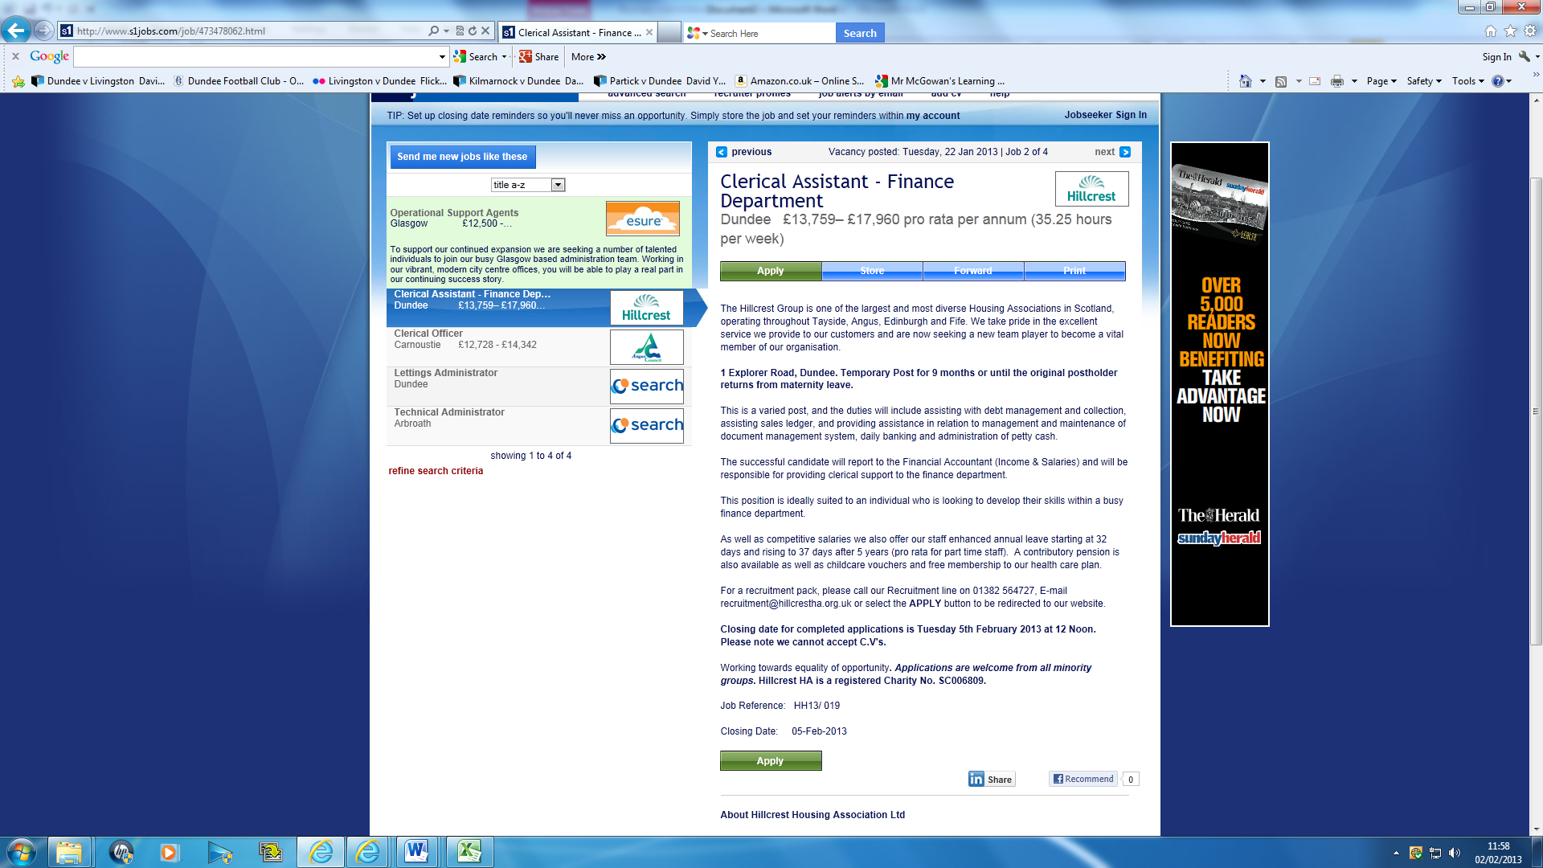

Now pass your jotter clockwise at your table for marking.

Remember to mark your peer’s work neatly!!



**ACTIVITY 3/EXTENSION ACTIVITY**

What have we learned so far?

In Microsoft Word create a table with 2 columns and 9 rows (see below).

Use your notes to complete a glossary for the following key terms.

|  |  |
| --- | --- |
| **GLOSSARY OF TERMS** | |
| **JOB DESCRIPTION** |  |
| **PERSON SPECIFICATION** |  |
| **ESSENTIAL** |  |
| **DESIRABLE** |  |
| **APPLICATION FORM** |  |
| **CV** |  |
| **SKILLS** |  |
| **QUALITIES** |  |

**ASSESSMENT**

* Creating a Job Description and Person Specification
* Develop pair working and peer assessment skills



The following task should be completed in pairs. Once you have completed the task it will be ***peer assessed***, meaning that you and your partner will assess how each other performed during the task.

You will identify 2 positive points i.e. things that your partner did well and 1 point for improvement i.e. something that your partner should try to develop. Remember to look out for these points as you ***work together*** through the assessment.

**YOUR TASK…..**

1. You are employed in the Human Resources department of a local business and you have been asked to work with your colleague to prepare a job description and person specification for an Administration Assistant job.
2. Each document should be displayed on A4 paper and prepared using a computer. Remember to give your business a name and logo, which should be displayed on both documents.

(**HINT** – work together to prepare this on one computer then use your knowledge of e-mail to send it to your colleague. This ensures that they will be identical).

***To help you complete this activity***

* Refer to your class work for this unit.
* Refer to the sample job description and person specification saved in the Business Enterprise folder.
* Websites such as s1jobs.com, dundeecity.gov.uk, monster.co.uk, myjobscotland.gov.uk

**PEER ASSESSMENT**

Your teacher will give you a sheet to help you peer assess your partner.

*Remember you should use* ***positive language*** *in your assessment.*

**EXTENSION ACTIVITY**

Your manager has asked you to create a job advert for the Courier and Advertiser. Use the examples given by your teacher to help you complete this task.

**CUSTOMER CARE**

Customers can be both internal and external. It is important for staff to know how they are expected to behave towards colleagues – internal customers – as well as people who buy products and services – external customers

**MISSION STATEMENT**

Most organisations have an overall mission statement which gives a short statement of the main intentions of the organisation. A good mission statement should be able to tell stakeholders about an organisation and ideals, in seconds. It is important that everyone who works for the organisation knows and believes in its mission statement.

A mission statement is usually no longer than a paragraph and is written in language that everyone can understand. For example,

[Google](http://www.google.com/)

**Google’s mission is to organize the world’s information and make it universally accessible and useful.**

[](http://www.google.co.uk/url?sa=i&rct=j&q=primark+&source=images&cd=&cad=rja&docid=L2V6rr8odHmfmM&tbnid=p5ZlJQmoiOlC8M:&ved=0CAUQjRw&url=http://www.westwoodx.co.uk/shops/primark-0&ei=CsAaUfD-NI2V0QXZ94HQBw&bvm=bv.42261806,d.d2k&psig=AFQjCNGwBff_MXz31P30nUlu5B1eBPW_bg&ust=1360793977758531)

“**To supply quality clothing at prices perceived to offer real value.”**

**GOOD CUSTOMER SERVICE**

Organisations must look after their customers. To achieve this they must provide good service. If a business wants to survive in the market place they must retain loyal customers and attract new ones. Good customer service is about:

* putting the customer first
* good after-sales service
* having knowledgeable, trained staff

[](http://www.google.co.uk/imgres?q=customer+service&start=300&um=1&hl=en&sa=N&tbo=d&rlz=1R2ADRA_enGB516&biw=1920&bih=924&tbm=isch&tbnid=6mPaUsjbHSDkyM:&imgrefurl=http://level343.com/article_archive/2012/11/26/customer-service-should-be-your-first-branding-exercise/&docid=ShOicxxl0xYmEM&imgurl=http://level343.com/article_archive/wp-content/uploads/customer_service-article.jpeg&w=300&h=300&ei=LoMiUZSHGoba0QXOy4DABQ&zoom=1&ved=1t:3588,r:63,s:300,i:193)The effects of good customer service are:

* customers will come back to the organisation
* customers will recommend the business to their friends
* increased sales
* fewer complaints
* good reputation

**POOR CUSTOMER SERVICE**

Poor customer service can arise due to;

* poor communication
* lack of staff training
* not listening to customer feedback
* absence of clear complaints procedure

Poor customer service can have serious implications for a business, as follows;

* The organisation will gain a bad reputation
* Customers will take their business elsewhere

[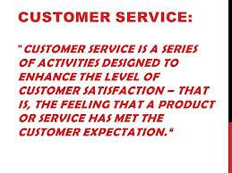](http://www.google.co.uk/imgres?q=customer+service&start=116&um=1&hl=en&sa=N&tbo=d&rlz=1R2ADRA_enGB516&biw=1920&bih=924&tbm=isch&tbnid=T9rLviM8n7U57M:&imgrefurl=http://www.eagleonline.com/a-customer-service-attitude/&docid=g73o06EbpgNtdM&imgurl=http://www.eagleonline.com/wp-content/uploads/Customer-service-3.jpg&w=960&h=720&ei=7oIiUaOoE6nA0QX97YDoAw&zoom=1&ved=1t:3588,r:42,s:100,i:130&iact=rc&dur=178&sig=100532141430501027914&page=4&tbnh=180&tbnw=240&ndsp=39&tx=61&ty=45)

* A loss of sales revenue and reduced profit
* Staff may be made redundant
* Remaining staff may lack motivation

[](http://www.google.co.uk/imgres?q=good+v+bad&start=203&um=1&hl=en&rlz=1R2ADRA_enGB516&biw=1920&bih=901&tbm=isch&tbnid=5KSRWRDb7NCI9M:&imgrefurl=http://pmtips.net/good-pm-consultant-bad-employee/&docid=z7-TVe0EpM4UIM&imgurl=http://pmtips.net/wp-content/uploads/2012/02/good-and-bad.jpg&w=292&h=341&ei=ATIlUYGwKuaL4gSkwYGYBA&zoom=1&ved=1t:3588,i:139&iact=rc&dur=319&sig=100532141430501027914&page=6&tbnh=190&tbnw=163&ndsp=44&tx=88&ty=87)[](http://www.google.co.uk/imgres?q=good+v+bad&um=1&hl=en&rlz=1R2ADRA_enGB516&biw=1920&bih=901&tbm=isch&tbnid=XBOsAa-LAdNfSM:&imgrefurl=http://depositphotos.com/10918462/stock-photo-Good-Vs-Bad-Dice-Lucky-Roll-to-Decide-Answer.html&docid=glneHdetH6iVQM&imgurl=http://static9.depositphotos.com/1005979/1091/i/950/depositphotos_10918462-Good-Vs-Bad-Dice-Lucky-Roll-to-Decide-Answer.jpg&w=950&h=876&ei=zTElUYeHHamH4ASixoHwDw&zoom=1&ved=1t:3588,i:194&iact=rc&dur=283&sig=100532141430501027914&page=1&tbnh=179&tbnw=230&start=0&ndsp=32&tx=68&ty=83)

**Activity 4**

* Use the short questionnaire issued by your teacher

* Interview your partner to identify an example of good customer service they have received
* And an example of bad customer service they have received.

* Once you have completed your interview, create a short report on your findings, using Word

**ACTIVITY 4**

Good customer service v bad customer service



**HEALTH & SAFETY IN THE WORKPLACE**

The Health & Safety at Work Act (1974) defines the responsibilities of the ***EMPLOYER***and the ***EMPLOYEE*** to ensure the health, safety and welfare of people at work.

If a business has 5 or more employees, it is required by law to have a Health & Safety Policy, containing the following information;

* The business’s commitment to Health & Safety
* Procedures for dealing with accidents and injuries
* Procedures for dealing with fire prevention
* Procedures for dealing with training all employees on health and safety issues.

All employees should receive a copy of the policy during their induction training.

**EMPLOYER RESPONSIBILITIES**

* Prepare a H&S policy so that staff are aware of the policy and procedures.
* Look after employee’s welfare, for example, free eye tests
* Provide First Aid facilities
* Provide information and training
* Keep records of any accidents or incidents that occur
* Provide protective clothing and equipment if necessary, for example, protective hats

[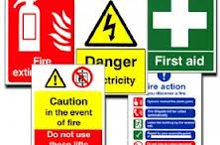](http://www.google.co.uk/imgres?q=reason+for+health+and+safety+legislation&hl=en&sa=X&tbo=d&rlz=1R2ADRA_enGB516&biw=1920&bih=924&tbm=isch&tbnid=p3kz6uXpnNHsqM:&imgrefurl=http://2012.mtdcnc.com/used-machine-tools/trawl-TOS-FNK-25-TURRET-MILL-40-Int-Spindle-16-S-2012829-180.asp&docid=MYYZiH1Z1NiAjM&imgurl=http://2012.mtdcnc.com/uploads/news-events/home-news-slider/health-safety.jpg&w=278&h=183&ei=iIMOUZqKKIi90QX204CgDg&zoom=1&ved=1t:3588,r:26,s:0,i:169&iact=rc&dur=265&sig=100532141430501027914&page=1&tbnh=145&tbnw=221&start=0&ndsp=35&tx=167&ty=108)

**EMPLOYEE RESPONSIBILITIES**

* Take care of their own health and safety
* Take care of their colleagues’ health & safety
* Cooperate with employers’ policy and procedures
* Do not interfere or misuse equipment
* Report any accidents or faulty equipment

**HAZARDS AND FAULTS**

A **HAZARD** is an object, the way something is done or some situation, which has the potential to be dangerous.

A **FAULT** is when machinery and equipment do not work in the way they were designed to work.

**ACTIVITY 1**

Distinguish between hazards and faults



Copy the table below into your jotter. For each scenario, **identify** whether it is a hazard or a fault and **suggest** safety measures you could take to protect yourself and your colleagues against danger.

|  |  |  |  |
| --- | --- | --- | --- |
|  | | **HAZARD OR FAULT?** | **HOW TO MAKE IT SAFE?** |
| j0237196[1] | Filing cabinet drawer is left open |  |  |
| j0295823 | Kettle does not switch off when water is boiled |  |  |
|  | Leaning back and/or swinging on an office chair |  |  |
| j0274796[1] | Electric shock from socket |  |  |

**REPORTING AN ACCIDENT**

All accidents which happen in the workplace must be recorded by the employer. If an accident happens in school Mrs Elder is responsible for recording the details.

This provides an accurate record of the accident and helps to monitor accidents which have occurred and prevent them happening again.

**ACTIVITY 2**

Accident Waiting to Happen



Below is a photograph of a corridor outside the mail department of Graphic Images Ltd. The picture was taken last Friday afternoon. Unfortunately, Mrs Robertson (who works in the Administration Department) tripped over one of the bags and broke her ankle. Her assistant, Hannah Morrison, saw Mrs Robertson’s accident and phoned the first aid representative. An ambulance was called and Mrs Robertson was taken to hospital.

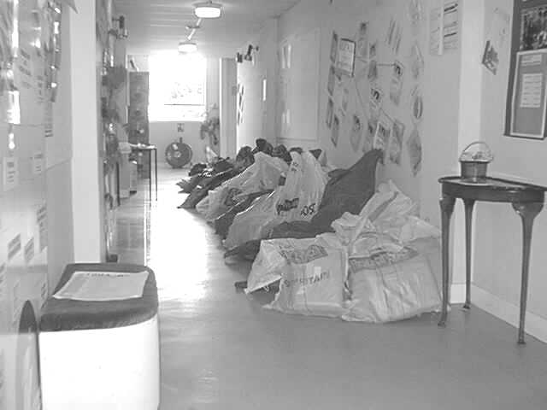

* Study the photograph above.
* Locate and open Activity 2 – Accident Waiting to Happen.
* Complete the accident report form.
* Print one copy and give it to the Human Resources Manager (your teacher!!) to check and sign.

**SECURITY**

Security measures should be taken to protect and reassure staff, to prevent the theft and to maintain the security and confidentiality of information.

**SECURITY OF STAFF**

To ensure that only authorised personnel have access to the premises an organisation can use a combination of the following methods;

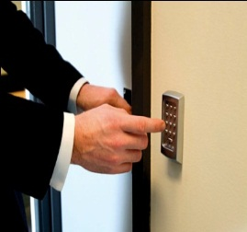

* Staff sign in/out book
* [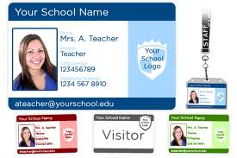](http://www.google.co.uk/imgres?q=id+badges&hl=en&sa=X&tbo=d&rlz=1T4ADRA_enGB516GB516&biw=1920&bih=924&tbm=isch&tbnid=lge-IOXmRiOK4M:&imgrefurl=http://www.jhpschools.com/id-badges.html&docid=hUzFCvf8xX5zxM&imgurl=http://www.jhpschools.com/idbadgesbig.png&w=600&h=400&ei=xqkOUYzhFsed0QXJuIDoCg&zoom=1&ved=1t:3588,r:38,s:0,i:258&iact=rc&dur=703&sig=100532141430501027914&page=2&tbnh=180&tbnw=270&start=34&ndsp=43&tx=155&ty=107)Intercom/security door/CCTV
* Staff Identification (ID) badges
* Controlled use of keys

**VISITORS TO THE BUSINESS**

To ensure that only genuine visitors enter the premises a business can use a combination of the following methods;

* Visitors must report to reception on arrival

[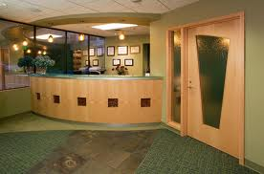](http://www.google.co.uk/imgres?q=office+reception+area&hl=en&sa=X&tbo=d&rlz=1T4ADRA_enGB516GB516&biw=1920&bih=924&tbm=isch&tbnid=mVrwbiXO6Rek7M:&imgrefurl=http://www.tciincgc.com/lv2-03-drbauman.html&docid=i7rw1HHdCFMD4M&imgurl=http://www.tciincgc.com/images/level2/03-drbauman01b.jpg&w=800&h=529&ei=O6oOUZCMPIqw0QXo_YGwCg&zoom=1&ved=1t:3588,r:39,s:0,i:204&iact=rc&dur=213&sig=100532141430501027914&page=2&tbnh=170&tbnw=248&start=30&ndsp=36&tx=161&ty=107)

* Reception should be located at the entrance to the organisation
* Visitors passes issued and displayed
* Visitors should not be left unsupervised
* The receptionist should ensure all visitors leave the building and that passes are returned

**SECURITY OF INFORMATION**

In accordance with the Data Protection Act an organisation should use a combination of the following methods to ensure the security of information;

* Use of passwords – these should not be obvious and be changed regularly
* Use read only files – files that can be read but not amended
* Virus screening software should be used to ensure that files are not lost
* Use of locked rooms, filing cabinets and computers
* Confidential documents should be discarded appropriately (eg shredded)

**SECURITY OF EQUIPMENT**

A business will also use security to prevent equipment being stolen such as;

* CCTV
* A register of serial numbers of computers, printers etc. (have a look at the computers in your Business Enterprise classroom)
* Use of ultraviolet markers to identify equipment

**ACTIVITY 3**



**In your jotters, answer the following questions.**

|  |  |  |
| --- | --- | --- |
| 1. | Identify what is meant by HASAWA. | **1** |
| 2. | HASAWA places responsibilities on employers and employees. Identify 2 responsibilities for   1. The employer 2. The employee | **4** |
| 3. | What should a visitor be issued with at reception? | **1** |
| 4. | Identify 3 areas of an organisation where security is very important and explain why. | **6** |
| 5. | Identify 3 ways an organisation can ensure the security of their staff. | **3** |
| 6. | Where should a reception area be situated? Why? | **2** |
| 7. | Suggest 2 steps an organisation can take to ensure information on a computer is held securely. | **3** |
|  | **TOTAL** | **20** |