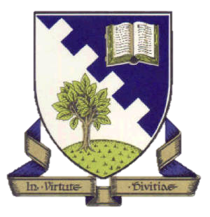

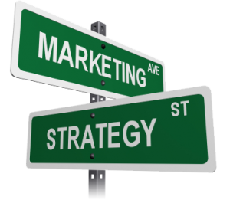

Unit 3

Marketing

S2 Business Enterprise & ICT

Introduction to Unit

The main focus of this unit is to explore how businesses meet the needs and wants of customers.

After working through this unit you will be able to:

* Explain the term **marketing**
* Understand why **marketing is important**
* Know what is meant by **Market Segmentation** and give examples
* Examine the main elements of the **Marketing Mix (4 P’s)**
* Investigate different well-known **brand names**
* Distinguish between different methods of **promotion**

[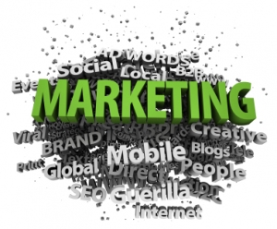](https://crowdfunduk.files.wordpress.com/2012/04/marketing.jpg)

WHAT IS MARKETING?

Marketing is the process of developing, promoting and distributing products to satisfy customer needs.

By satisfying customers’ needs, a business is more likely to receive repeat purchases. It is therefore in the interest of the business to research the specific needs of customers and supply products customers want.



Marketing is about making sure that:

* The right **product,**
* Is at the right **place,**
* At the right **time,**
* At the right **price!**

Marketing is important to business as it:

* Makes sure they **provide products customers actually want**
* **Makes customers aware** of the products/services they sell
* **Persuades customers** to buy the products services they sell
* **Finds out** what customers **want now**
* **Predicts** what customers **might want in the future**

WHAT IS MARKETING SEGMENTATION?

To target markets appropriately, business must split the market up into segments. No individual will have exactly the same need as another, but those who have similar wants and needs can be grouped together.

These different groups can be researched to identify what products or services are most appropriate. The market can be split into many different segments:

[](http://tripazon-review.com/wp-content/uploads/2012/03/ReachingTargetMarket.jpg)

* Age
* Gender
* Income
* Geographical Location
* Religion

Once the different market segments have been identified, a marketing strategy (or Marketing Mix) will be created by the business.



WHAT IS THE MARKETING MIX?

The **Marketing Mix** is the mix of the key elements of a marketing strategy.

There are **4 factors** a business must consider when creating its **Marketing Mix.** These factors are known as the **4 P’s.**

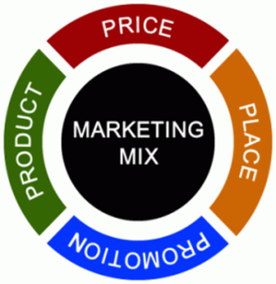

* ***PRICE*** – what price do you charge?
* ***PRODUCT*** – what is your product/service?
* ***PROMOTION*** – special offers/advertising
* ***PLACE*** - where can customers buy it from?

**Businesses carefully plan the Marketing Mix** – or come up with a plan or “**strategy**” to sell as many products/services as possible.

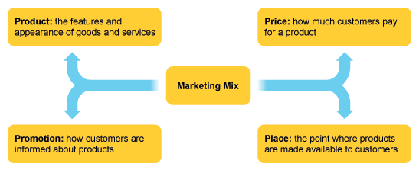

Task 1



* Copy the **Unit 3 – Marketing folder** to your library
* Access the Marketing Mix Interactive Resources
* Explore the 4 elements of the Marketing Mix
* Complete the **Business Activity**
* **Complete Quiz** (you can review notes at any time)
* **Print** one copy of your completed Quiz

BRANDING

A **brand** is a product or range of products with an easily recognisable character – a name, symbol or slogan.

[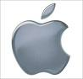](http://www.google.co.uk/imgres?imgurl=http://gawker.com/assets/resources/2008/03/apple.jpeg&imgrefurl=http://gawker.com/?_escaped_fragment_=374234/apple-logo-makes-you-creative-really&h=480&w=501&sz=19&tbnid=vffUrwpSGTl7MM:&tbnh=125&tbnw=130&prev=/search?q=apple+logo&tbm=isch&tbo=u&zoom=1&q=apple+logo&hl=en&usg=__I7Uh3sFDcytfwd66uqTtY0PHAEc=&sa=X&ei=hVfSTfbwFsL1-gblsZnKCg&ved=0CDMQ9QEwBQ)[](http://www.google.co.uk/imgres?imgurl=http://10thing.com/wp-content/uploads/2010/10/microsoft-logo.jpg&imgrefurl=http://10thing.com/technology/microsoft-os&h=299&w=300&sz=5&tbnid=Sk8jPaSR61onuM:&tbnh=116&tbnw=116&prev=/search?q=microsoft+logo&tbm=isch&tbo=u&zoom=1&q=microsoft+logo&hl=en&usg=__unRn0zkVYmjgWA06xXdq12fD8HY=&sa=X&ei=i1jSTb7KJc-e-wakzeGyCg&ved=0CCAQ9QEwAg)

[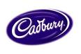](http://www.google.co.uk/imgres?imgurl=http://www.chocolatefare.com.au/Cadbury%20logo.bmp&imgrefurl=http://www.chocolatefare.com.au/links.htm&h=369&w=550&sz=793&tbnid=ZgJ6nmocQpg1GM:&tbnh=89&tbnw=133&prev=/search?q=cadbury+logo&tbm=isch&tbo=u&zoom=1&q=cadbury+logo&hl=en&usg=__U1V-djaGajvMwj3rtFQWfN1FrOk=&sa=X&ei=-FfSTZy1Icr1-ga08LncCg&ved=0CDgQ9QEwBA)[](http://www.google.co.uk/imgres?imgurl=http://www.enterprise.mtu.edu/highschool/partners/logos/ibm-logo.jpg&imgrefurl=http://www.enterprise.mtu.edu/highschool/partners/index.html&h=329&w=329&sz=4&tbnid=2d1dY_-URTE_GM:&tbnh=119&tbnw=119&prev=/search?q=ibm+logo&tbm=isch&tbo=u&zoom=1&q=ibm+logo&hl=en&usg=__I34ofcB3eAyRGpdX8i0QdgmT5TI=&sa=X&ei=F1jSTePpMIqf-Qaqzp3NCg&ved=0CCIQ9QEwAA)[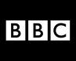](http://www.google.co.uk/imgres?imgurl=http://nickbaines.files.wordpress.com/2009/08/bbc-logo.jpg&imgrefurl=http://nickbaines.wordpress.com/2009/08/29/long-live-the-bbc/bbc-logo-2/&h=360&w=450&sz=14&tbnid=Z7G5fsyh3vnNlM:&tbnh=102&tbnw=127&prev=/search?q=bbc+logo&tbm=isch&tbo=u&zoom=1&q=bbc+logo&hl=en&usg=__W7SA-vtpqtfgccdgFRhsJ7cpE4I=&sa=X&ei=v1fSTbXzGoGk-gaU0pHOCg&ved=0CDUQ9QEwAw)

For example we all recognise Coca-Cola or Cadbury not only by the logo but by the packaging, taste, advertising and other features. The aim is to make the product **recognisable to the consumer** and appear different so that customers believe they are better.

Small children who cannot read will often recognise a brand simply by its logo which is an image they recognise and which they can relate to a certain product or business.

A **global brand** is a **well-known and easily recognised product** which is advertised and sold in countries across the world.

These products are usually made by **multinationals**, companies which operate in more than one country.

Task 2

* Access the File **Task 2 – Brands**
* Use the internet to gather the information required
* Insert your Name and Class in the footer
* Print a copy on one sheet of paper (2-sided)

PROMOTION

Promotion is carried out by the Marketing Department and involves some or all of the following activities.

**ADVERTISING**

The main **TYPES** of advertising and their aims can be seen below.

|  |  |  |
| --- | --- | --- |
| **Type** | **Features** | **Examples** |
| j0217328**INFORMATIVE ADVERTISING** | This type of advertising aims to simply give people facts for their use. | * Tax adverts * Health adverts * Product recall adverts |
| j0232476**PERSAUSIVE ADVERTISING** | This type of advertising aims to persuade people to change their habits and so buy (or do) something new instead. These adverts often focus on USP’s and brand image. | * Product adverts |

The main METHODS (ways) of advertising that a business can use are below.

|  |  |  |
| --- | --- | --- |
| **Method** | **Examples** | **Features** |
| j0186162**BROADCAST ADVERTS** | * TV * Radio * Cinema * Internet | These methods are **ATTENTION GRABBING**, but usually only **LARGE** businesses can afford the **HIGH COSTS** ofusing them for **WIDE** market coverage. However, **SMALLER** businesses may also be able to afford limited use for their small markets, eg **MICRO REGIONS**. |
| j0323759**PRINTED ADVERTS** | * Newspaper * Local Paper * Magazines * Journals * Flyers * Letters | These methods provide **LOYALTY** and **BELIEVABILITY**, but usually only **LARGE** businesses can afford the **HIGH COSTS** of **WIDE** market coverage. However, **SMALLER** businesses may also be able to afford limited use for their small markets, eg **LOCAL PAPERS**. |
| j0250536**OUTDOOR ADVERTS** | * Bus Posters * Taxi Posters * Shelter Posters * Billboards * Street Posters | These methods are **ATTENTION GRABBING**,but usually only **LARGE** businesses can afford the **HIGH COSTS** of **WIDE** market coverage. However, **SMALLER** businesses may also be able to afford limited use for their small markets. |

When preparing adverts, the following ideas should be considered:

* SLOGANS (a saying for the product – eg the future is Orange)
* JINGLES (short saying made into a song – eg always Coca Cola)
* SONGS (eg “I’m so excited” – Crunchie)
* BRANDING (identity and image that people identify with)
* CELEBRITY ENDORSEMENTS (Jamie Oliver & Sainsbury’s)

**PROMOTIONAL ACTIVITIES**

The aim of the promotional activities is to encourage buyers to buy products by giving them a special offer. The main methods of promotion that a business can use are:

* 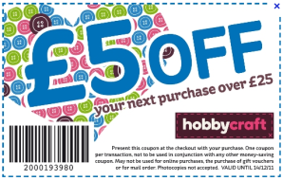BUY ONE GET ONE FREE (BOGOF)
* SPECIAL OFFERS (20% extra free)
* DISCOUNTS (10% off)
* 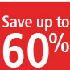MONEY OFF VOUCHERS
* FREE GIFTS
* COMPETITIONS
* FREE SAMPLES/TASTINGS

Task 3

* Access the File **Task 3 - Promotions**
* Use your notes and interactive resource to help you
* Insert your Name and Class in the footer
* Print a copy on one sheet of paper (2-sided)