S3 Business Enterprise & ICT
Unit 1 – Business Basics

Introduction to Unit

This unit builds on prior knowledge from S2 and further explores the economic factors that influence business survival or failure.

The main focus of this unit is to explore the business world around you by investigating the local environment and to explore the features of different business types.

Prior Knowledge:

- Difference between a need and want
- Difference between a good and service
- Factors of Production
- Cycle of Business

After working through this unit you will be able to:

- Explain what is meant by the basic economic problem
- Examine economic factors that influence whether businesses survive or fail
- Distinguish between different types of business organisations
- Research the features of different business organisations within Broughty Ferry & Dundee
- Explain the different objectives that business organisations may have
- Understand the interests that different stakeholders have and how they influence organisations
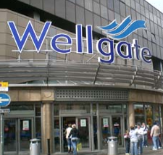
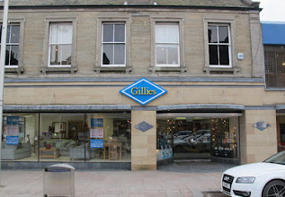

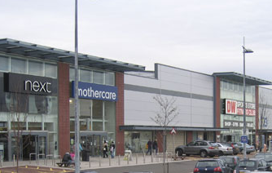
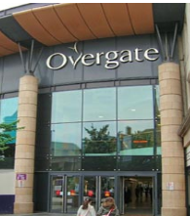

The basic economic problem

You have probably heard the word “economics” before; we hear it on the news, see it in newspapers and hear people talking about it. But what does it actually mean?

Economics is about how the business world works and how it reacts to things that are going on around it. This is known as the external or economic environment.

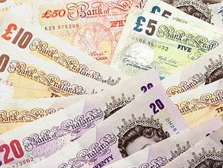
Decisions have to be made by individuals and businesses because of one main reason – there isn’t enough money or goods and services in the world to be able to have everything we want. This is known as the basic economic problem. Because of this, we have to make a choice, for example do you buy a CD or new clothes with your pocket money?

Economic Factors

Many new and existing businesses fail; in other words they do not have the necessary resources (eg money) to continue to exist. Sometimes this is because of economic or external factors such as the ones shown below.

Too much competition

Businesses all face competition. It could be that a small butcher in your local high street has to compete against a larger retailer in the same town, or one large retailer has to compete against another one. In order to attract and keep customers, businesses have to offer incentives to customers to shop with them. These incentives could be special offers, lower prices or discounts. Because larger businesses have more power they can usually afford to have better incentives than smaller businesses and this can put smaller businesses out of business! Larger businesses can take advantage of economies of scale (discounts on bulk buying) and offer products cheaper than smaller retailers.

When new businesses open there are many advantages:

- More choice of where to shop
- Often cheaper products because of economies of scale
- More jobs for people in the local community
- The government gets more money from taxes
- Better facilities (eg new roads)

However, when a business fails there are many disadvantages:

- People are made unemployed (and there are larger consequences of this).
- The government receives less money in tax and has to pay benefits to the unemployed.
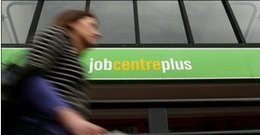

Not enough demand
Demand refers to how much people want something. When demand for a product is high (such as when a new product is launched) prices tend to be very high. This is because businesses can charge more money for a product that is in limited supply. As demand begins to decrease, businesses often decrease the price of the product in order to create more demand. This is why businesses have sales; the price of the product is reduced which encourages people to buy it (and demand increases).

Recession

This is a word that you may have heard on the news but what does it actually mean? When the demand for goods and services is low and unemployment is high over a period of time, an economy is said to be in recession. During a recession, many businesses fail and the number of people becoming unemployed increases. The consequences of this are a bit like a “vicious circle” and can be shown in the following diagram.

To help the economy come out of recession, the government will usually take action. This might include cutting interest rates, injecting money into specific parts of the economy and reducing VAT (Value Added Tax).

Summary of economic factors

We all live in an economy that is constantly changing. It is important to know what is happening around us because it will impact upon our lives and the lives of others. Businesses can fail because of different economic factors and this can have many consequences for us and the economy.

Economic Factors – Pupil Tasks

Answer the following questions in sentences in your Business Enterprise jotter.

Q1 Describe in your own words what you understand by the term “economics”. 1

Q2 Outline 3 different reasons why a business may fail. 3

Q3 Identify 3 advantages of increased amounts of competition. 3

Q4 Can you suggest one advantage that a small local butcher (eg Scott Brothers) has over larger retailers such as Asda or Sainsbury’s meat products? 1

Q5 Explain what happens when a business decreases the price of its products and services? 1

Q6 Suggest 2 other incentives that businesses could use to encourage customers to shop with them rather than the competition. 2

Q7 Describe in your own words what you understand by the term “recession”. 2

Q8 Outline 2 consequences of a recession. 2

Total Marks = 15

Economic Factors – Practical Activities

Undertake at least one of the following practical activities:
Option 1 - Has a large retailer opened up in Broughty Ferry or the Dundee area recently?

Outline the impact this has had?
Remember, the impact can be good and bad.
Consider the impact to other businesses and the customer

Present your thoughts using a suitable format using either:
- Word (one page)
- PowerPoint (one slide)

The completed practical activity should be presented professionally displaying your full name.

Option 2 - In pairs, come up with as many consequences as you can of increasing unemployment.

Think about the consequences for:

- Individuals
- Businesses
- Local community

Insert an appropriate heading in your jotter and note down your discussions.

Option 3 - Identify current incentives large retailers give to encourage customers.

- What can businesses do to persuade customers to shop with them?
- What can businesses do to improve demand for products/services?
- Think about current promotions advertised on TV
- Use the internet to research incentives currently offered by retailers
- Are there any current incentives that have encouraged you to shop with a particular business!

Present your thoughts using a Word document with suitable graphics.

The completed practical activity should be presented professionally displaying your full name.

business organisations

Our society is made up of many different types of business organisations. In our everyday lives, we interact with them, depend on them and work for them.

There are 3 main sectors of business within the UK economy.

Private Sector

Businesses that are owned by ordinary people and can range from very small businesses which are owned by one person to large firms owned by many thousands of people.

Public Sector

This sector of the economy is owned and operated by the Government on behalf of the public.

Voluntary Sector

This sector of the economy is made up of Charities and other not-for-profit organisations.

private sector organisations

Regardless of the size of business, one of the main reasons for being in business is to generate income and profits. This can be done by operating as a:

- Sole trader
- Partnership
- Limited Companies (Private and Public)
- Franchise
- Co-operatives

Sole trader

A sole trader is a business that is owned and managed by one person. They are responsible for the operation and running of the business. Examples of this type of business include local newsagents, hairdressers and tradespeople such as plumbers and electricians. Although many sole traders will employ a few workers, the ownership remains in the hands of the sole trader. Sole traders are the most common form of business ownership in the UK.

Advantages of being a sole trader | Disadvantages of being a sole trader
- The business is usually small-scale, so small amounts of investment (capital) are required to set-up. | - The sole trader has unlimited liability. This means that if the business is unsuccessful the owner could lose their personal possessions such as their home and car.
- It is easy for the owner to keep overall control because of the small-scale nature. They make all decisions and can make them quickly! | - The sole trader has full responsibility and must make all of the decisions and will normally work long hours. There is no-one to share the workload with if there are no employees.
- They can offer a more personalised service compared to larger businesses resulting in good customer loyalty | - It can be difficult to raise finance as banks may be reluctant to lend you money.
- It is easy to set-up, no legal paperwork required. | - If the owner is ill or on holiday, work has to stop and no money is coming in.
- All profits are kept by the owner.

Partnership

A partnership is a business made up of at least 2 people (but less that 20) who are in business together. It is the preferred option for professionals such as accountants, lawyers, solicitors, doctors and vets. A sole trader may expand and become a partnership if the owner decides that someone else is needed to help run the business.

A Partnership Agreement is a legal document which is drawn up between the partners. It will set out essential details such as the capital put in by each partner, how partners will share profits and losses, how the business will operate, areas of responsibility and salary received by partners.

Advantages of being a partnership | Disadvantages of being a partnership
- Partners bring new skills and ideas to a business. Partners may have expertise in different areas so they can specialise. | - The partners have unlimited liability. This means that if the business is unsuccessful all the partners could lose their personal possessions such as their home and car.
- Partnerships can raise more capital as there are more owners to contribute. | - Profits have to be shared between partners.
- Responsibility and decision-making is shared – so there is less pressure on one individual. | - Dispute and disagreements can take place between the partners over the direction of the business.
- It is easy to set-up, no legal paperwork is required although a Partnership Agreement is strongly advised! | - If one partner leaves this can upset the running of the business.

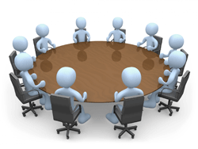

Limited Companies

A Limited Company can be either private or public. It must have at least 2 shareholders who are the owners of the business. It is usually run by a Board of Directors who are responsible to the owners/shareholders of the business.

Private Limited Company

Private Limited Companies must have the word “limited” or the letters “Ltd” after their name and they are not allowed to trade their shares on the stock market. They are described as being “private” as shareholders have to be invited to become owners and cannot be purchased by members of the general public. Private Limited Companies tend to be owned by families who all own a certain number of shares.

Public Limited Companies

Public Limited Companies must have the letters “Plc” after their name and they are allowed to trade their shares on the stock market. Large companies tend to operate as a plc. The owners often lose control over decisions because it is the shareholders who appoint the Board of Directors to oversee the running of the business.

All limited companies must register with the Registrar of Companies which is based at Companies House in Edinburgh – for Scottish companies.

There are 2 main legal documents which apply to limited companies:

- Memorandum of Association
- Articles of Association

These documents set out:

- The details of the company
- The aims of the company
- How it will be run and financed

Advantages of being an LTD | Disadvantages of being an LTD
- Shareholders have limited liability, the liability of shareholders are limited to the amount they have invested in the company. This means that if the business fails, each shareholder only loses the amount put into the business. | - Profits are shared amongst more people – shareholders receive a share of the profits known as a dividend. The original owners of the company may lose control.
- Capital (money) can be raised from inviting shareholders to buy shares in the business. | - There is a legal process involved in setting up the business. The business must abide by the rules of the Companies Act.
- Shareholders may have experience and expertise they can bring to the business. | - The details of the business are available to the public. Detailed records of spending, income and profits must be given to shareholders and the Registrar of Companies in Edinburgh,

Advantages of being a PLC | Disadvantages of being a PLC
- Shares can be traded on the stock market | - Set-up costs of “floating” a business on the stock market are high. A prospectus with detailed business information must be available to potential shareholders.
- Easy to raise large amounts of finance due to their size
- Shareholders have limited liability. If you bought shares on the stock market your losses are limited to how much you invested. | - Many legal documents are required to set up a plc – it is complicated and expensive.
 | - Plc’s must publish their yearly accounts. They are available to shareholders, the public and competitors for inspection!
- They can sell shares at any time so this means they can raise finance easily for large projects. | - They have no control over who buys their shares.
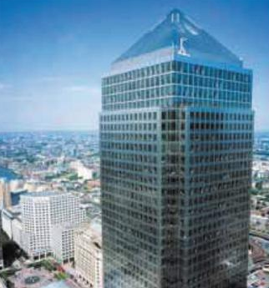 | - Sometimes plc’s can become so large that they become inefficient and are unable to remain competitive within the market

Franchises
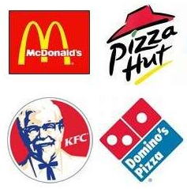
A franchise is a business which operates under the name of another business. It allows an individual or group of individuals to use an established business name and sell the business’s products or services. There are many successful franchises such as Subway and the Body Shop.

The franchisee pays to operate with the business name. The person or firm who owns the business is called the franchisor.

Advantages of being a franchise | Disadvantages of being a franchise
- Business benefits from established reputation and brand name is already well-known to customers. | - The franchisee is told exactly how to run the business – store layout, products to sell, prices, promotions.
- Economies of scale – bulk buying of ingredients and stock | - Franchisee can only purchase from the franchisor.
- Franchisor will advertise nationally therefore little advertising needs to be done by the franchisee. | - Franchisor will receive a percentage of the profits or a royalty from each individual franchise.

Co-operatives
A co-operative, or co-op, is where a number of individuals or businesses work together to achieve a common purpose. They are normally formed so individuals and small businesses can benefit from being part of a larger group, meaning they have more power to buy or bargain.
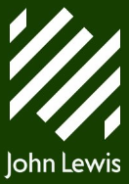
Co-ops are normally more focussed on the members of the co-op (either workers or customers), the local community and the world community and not just making profits for the owners.

Advantages of being a co-op | Disadvantages of being a co-op
- Lower costs due to economies of scale | - Long decision making process
- Employees or customers receive profits | - Difficult to raise money from banks

Private Sector – Pupil Tasks

Answer the following questions in sentences in your Business Enterprise jotter.

Q1 Identify 2 reasons why someone may decide to set-up a sole trader business. 2

Q2 State one disadvantage of being a sole trader. 1

Q3 Identify and copy which of the following phrases best explains the meaning of the term unlimited liability. 1

- The amount of capital put into the business is unlimited.
- The business has an unlimited amount of time in which to pay its debts.
- The owners are personally responsible for all of the businesses debts
- The business can supply an unlimited range of goods to its customers

Q4 Compare a sole trader with a partnership. (Identify the similarities and differences between the 2 types of businesses) 3

Q5 Outline 2 advantages of a partnership. 2

Q6 Name the legal document that should be created between partners. Identify 2 details that you think should be included in this document. 3

Q7 State the minimum number of shareholders in a Limited Company. 1

Q8 Limited companies can either be private limited (Ltd) or public limited (Plc). Explain the difference between an Ltd and a Plc. 1

Q9 Explain why a shareholder in a limited company has limited liability. 1

Q10 State one advantage and one disadvantage of a public limited company. 2

Q11 Describe the term “franchise” and give 2 examples of well-known franchises other than those given in the notes. 3

Q12 State one advantage and one disadvantage of a franchise. 2

Total Marks = 22

Private Sector – Practical Activities

Undertake at least one of the following practical activities:

Option 1 – In pairs, imagine you are setting up a partnership business and prepare a partnership agreement

- Decide what goods and/or services your business will sell
- Come up with a name for your business
- Decide how much each partner will invest into the business
- Decide how much of a wage each partner will receive
- Decide what areas of responsibility each partner will have

Produce the partnership agreement in Word using a suitable format.

The completed practical activity should be presented professionally displaying your full name.

Option 2 - Use the internet to research current franchise opportunities within the UK

Use the websites www.franchisedirect.co.uk or www.whichfranchise.com

Once you have researched the opportunities available, gather the following details for 3 franchises you like most:

- Company Name
- Brief outline of goods/services sold
- Amount of capital required to become a franchisee
- How you will be supported by the franchisor

Present your thoughts using a table in Word. The completed practical activity should be presented professionally using the company logos and display your full name.

PUBLIC sector organisations

Public sector organisations are owned and operated by the government on behalf of the public. The public sector provides a range of goods and services paid for through a variety of taxes. They do not need to make a profit to survive as they are funded by the government but they should aim to be effective and efficient. The public sector is made up of 3 different organisations:

- Central Government
- Local Government
- Public Corporations

Central Government

Central Government from both the Houses of Parliament in Westminster, London and the Scottish Parliament in Holyrood, Edinburgh provide the public with a variety of services such as:

- National Health Service (NHS)
- Social Security
- Ministry of Defence

Each year the government allocate a certain amount of spending in the “budget” to each service.

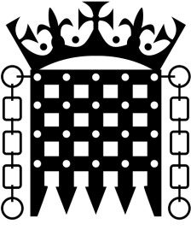
Each department/service will have a government minister who has overall control and provides guidelines to managers as to how the service should be run. The managers will make many of the decisions as to how the money could be spent to meet the government objectives.

Local Government

Local Government also known as Local Authorities or Councils receive the majority of their funding from the Scottish Government and Council Tax paid by people who live in the area.

The Local Authority uses the money it receives to provide the public with a variety of services such as:
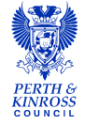
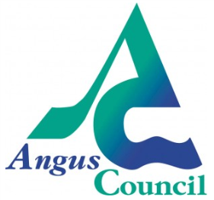
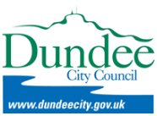
- Education
- Housing
- Leisure and recreation
- Street lighting
- Transport

The services they provide are essential for everyday life such as bin collection and bus service. Other services would be difficult for private sector businesses to operate such as street lighting and public parks.

Public Corporations

Public Corporations are also owned by the government but are run more like private sector organisations. The government appoints a Chairperson and a Board of Directors to run the Public Corporation on our behalf.

In the past there were many more public corporations but they were “privatised” (sold on the stock market) during the 1980’s.
The most well-known public corporation in the UK is the BBC – British Broadcasting Corporation. The BBC is funded by the public who pay a TV Licence of around £150 a year per household.

VOLUNTARY SECTOR

Organisations in the voluntary sector are in business to provide or raise money for a certain good cause. They are not in business to make a profit. Their aim is to maximise their potential to provide services through raising funds which are then used to further the cause.

Charities

Charities such as Oxfam and Help the Aged are examples of voluntary organisations. A Charity is the most common form of voluntary organisation in the UK.
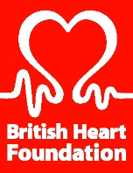
In order to be recognised as a charity, an organisation must meet certain criteria. It must have at least one of the following as its main aim:

- To relieve poverty
- To advance/promote education
- To advance/promote religion
- To carry out activities that benefit the community

Organisations that have been granted charitable status are exempt from paying VAT.

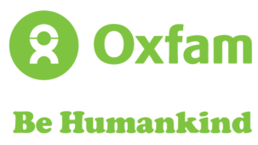
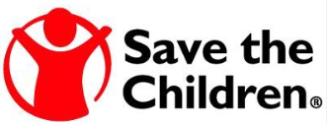

Social enterprise

Social enterprises have become an increasingly popular business type since the 1990’s.

The term “social enterprise” came about as there are more and more organisations using the power of business to bring about social and environmental change.

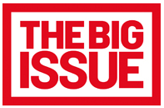
A social enterprise will have a clear sense of the difference it is trying to make, who it aims to help and how it plans to do it. It will bring all of its income through selling goods or services and will have very clear rules about how its profits will be reinvested to make social or environmental change.

Social enterprises come in many shapes and sizes from large national and international businesses to small community based enterprises but they are all set up specifically to make a difference.

They are different to Charities as they make profits by trading rather than through grants and donations.

Some of the most well-known social enterprises in the UK include the Big Issue, the Eden Project and Divine Chocolate.

There are also many community based social enterprises in and around the Dundee Area.

Public and Voluntary Sector – Practical Activities

Undertake at least one of the following practical activities:
Option 1 - Use the internet to research different services provided by the UK and Scottish Governments

Once you have researched the different services provided by central government, gather the following details for 3 different services.

- Service (area of spending)
- Approximately how much is spent on this service (£billions)
- Identify MP or MSP in charge of the service

Insert an appropriate heading in your jotter and note down your findings.

Option 2 – Use the internet to research at least 3 charities you know of

Once you have researched the charities, gather the following details:

- Identify the main aims of the charity
- How they raise funds to help their chosen cause
- What do they do with the money – what projects do they fund/undertake?

Insert an appropriate heading in your jotter and note down your findings.

Option 3 – Use the internet to research Social Enterprises that currently operate in the Dundee area

Use the website www.dundeesen.org

Once you have reviewed the directory of social enterprises that exist gather the following details for one business:

- Company Name
- What the business offers/specialises in
- Who they aim to help and how they plan to do it

Insert an appropriate heading in your jotter and note down your findings.

BUSINESS organisationS ASSIGNMENTS

Throughout the year you will undertake a number of formal assignments.

This work will become part of your Portfolio of Learning for Business Enterprise.

You must undertake all formal assignments.

BUSINESS ORGANISATIONS ASSIGNMENT 1

Match-it Task

Throughout the Business Basics Unit you will have encountered a number of new and unfamiliar terms.

You will need the following resources:

- Match-it task sheet
- Scissors
- Glue stick
- 1 x sheet of freeze paper
- 1 x A4 sheet of graphics to enhance your poster

This assignment will test how well you understand the terminology used in the world of business.

- Work in pairs or groups of 3
- One person should set an electronic stopwatch - www.online-stopwatch.com to time how long it takes you to match the key words with the definitions
- Cut out the key terms and definitions
- Work together as a team to match them correctly
- Get your teacher to check over your answers

- Effectively display the key terms and definitions as a memory map of the Business Basics Unit
- Arrange key terms into groupings that make sense/link together
- You are allowed one A4 printed sheet of colour graphics from clip art or the internet to enhance your Memory Map

This work will become part of your Portfolio of Learning for Business Enterprise.

You must undertake all formal assignments.

business organisations Assignment 2

Investigation of Local Businesses in Broughty Ferry

Throughout the Business Basics Unit you have learned about different types of businesses that exist.

You will need the following resources:

- Template Map(s) of Broughty Ferry Town Centre

This assignment will test your ability to apply your knowledge to the businesses that exist locally

- Working in pairs, fill in the names of businesses located in Broughty Ferry
- Insert photos of businesses or company logo
- Identify if each business is in the private, public or voluntary sector
- If private sector – identify the type of business organisation
- Identify the goods and/or services provided by each business
- Identify competitors of each business – in Broughty Ferry or Dundee
- Give reasons why the businesses are located in Broughty Ferry

The website www.cometobroughty.co.uk/index.htm has list of some businesses in Broughty Ferry.

You may also wish to use Google Street View – but beware, it is not up-to-date!

BUSINESS OBJECTIVES

Business organisations have different reasons for being in business. We call these objectives. An organisation’s objectives can depend on different things:

- Type of business
- Size of business
- The competition
- Type of goods or services that it provides

The following table gives examples of different business objectives and their meanings. Some organisations will try to focus on one or two objectives whilst others may try to achieve as many as possible. This will be decided by the owners of the business.

Objective | What it means
Survival | - This means to simply continue trading/operating as a business  - Smaller organisations may focus on this objective  - To avoid being taken over by other businesses and to continue operating in their own right
Profit Maximisation | - This is where the organisation aims to make as much money as possible.  - Costs/expenses are kept to a minimum  - Shareholders may focus on this objective  - Can be difficult to achieve other objectives as well as this one
Growth | - This is where the organisation tries to grow larger and increase its share of the market in which it operates  - It could try to do this by charging lower prices than its competitors to attract more customers
Social Responsibility | - This objective is increasingly important for the image of an organisation in the modern world  - Customers want to know that the business is responsible in its attitude to the environment or that it gives money to good causes  - Will have an impact on profits in the short term but will benefit the business in the long term
Being “green” (environmentally friendly) | - Many organisations now aim to reduce their “carbon footprint” and display a “green” image to their customers  - This is likely to become more important in the future  - Although it may cost the business money, it is likely to help generate more profits  - Also helps the business to be seen as “socially responsible”
Providing a Service | - This applies to most publicly funded organisations (government owned)  - Main aim is to provide a service that people require – eg health and education  - Although they are not in business to make a profit they must be managed efficiently and within budget

stakeholders

A stakeholder can be defined as a person or group of people (an organisation) who are interested in how successful an organisation is. They exist in all different types and sizes of organisations.

The most common stakeholders of an organisation are:

Private Sector | Public Sector | Voluntary Sector
Shareholders/owners  Board of Directors  Employees  Customers  Suppliers  Local Community  Bank/Lenders  The Government | Board of Directors  Taxpayer  Suppliers | Board of Trustees  Donors  Recipients

Each stakeholder will have a different interest in the organisation and will be able to influence what it does in different ways. Be careful, because interest and influences are different things:

- Stakeholder Interest – the reasons why a stakeholder takes an interest in what the organisation is doing

- Stakeholder Influence – the actions that the stakeholder can take that will impact upon the organisation and what it is doing
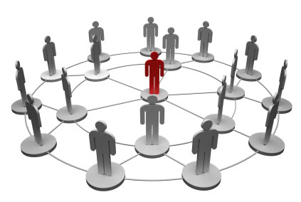

Private Sector Stakeholder – Interests and Influences

Stakeholder | Who are they? | What interest do they have? | What influence do they have?
Shareholders/  Owners | - The people who have invested capital into a business  - Shareholders are the owners of a limited company  - Sole traders/partnerships – the person/s who start the business with their own money | - The owner(s) will receive money in the form of profits  - Shareholders will receive dividends – a share of the profits | - Shareholders of a company have voting rights which give power to have a say in the way the company is run  - If the organisation is a sole trader or a partnership then the owners will make all the decisions affecting the business
Board of Directors | - The individuals who are employed to manage and run the organisation | - The Directors will receive a salary and other benefits such as a company car, bonuses, private healthcare for their work | - Make the decisions that affect the business in the long term – eg what to produce/sell
Employees | - The people who work for an organisation  - They provide the physical and mental labour the business needs to function | - Will receive a wage/salary for the work they do (may also receive other benefits or “perks”)  - They also expect to be treated fairly | - Can participate in various forms of industrial action (eg strikes, work-to-rule, go slow) if they are unhappy at work
Customers | - The people who purchase and consume the goods or services that an organisation provides | - They expect goods/services purchased to be of good quality  - They also expect to receive good customer service from the business | - If a customer is unhappy, they can decide not to purchase from the organisation and shop elsewhere (ie from a competitor)
Suppliers | - Provide organisations with the resources they need to operate  - Could provide anything from raw materials to stationery to cleaning services | - They hope to receive orders from the organisation  - They also expect to be paid for products they have sold to the organisation | - Can change the prices of the products they sell, delivery charges or credit they give to customers
Local Community | - The people who live near to where the organisation operates | - Interested in the jobs that will be provided by the organisation  - Interested in any negative impact – such as pollution, noise or traffic | - Can protest if they are unhappy at what organisation is doing  - Can complain to their MP/MSP
Banks/  Lenders | - Provide organisations with loans and other sources of finance that the organisation needs – eg mortgages and overdrafts | - They expect the business to repay the money owed to them on time with interest | - Can refuse to offer the organisation loans/overdrafts/mortgages  - Can change the rate of interest payable on loans
The  Government | - Responsible for providing essential services for the general public | - They hope businesses will provide people with jobs  - Interested in receiving money from the organisation and its employees through taxation | - Can change the amount of tax payable by the business and employees  - Can change/introduce laws that will affect the business  - Can grant/refuse planning permission

Public Sector Stakeholder – Interests and Influences

Stakeholder | Who are they? | What interest do they have? | What influence do they have?
Board of Directors | - These are the individuals who are employed to manage and run the organisations on behalf of the government  - Accountable to the government | - The Directors will receive a salary and other benefits such as a company car, bonuses, private healthcare for their work | - Make the decisions that affect the business in the long term – eg what to produce/sell
Taxpayer | - Members of the public who provide the government with money through their wages or by consuming (buying) goods and services | - They are interested in where their money goes and what they get in return for paying tax | - Can complain to their MP/MSP if they are unhappy with the services provided by the government
Suppliers | - Provide organisations with the resources they need to operate  - Could provide anything from raw materials to stationery to cleaning services | - They hope to receive orders from the organisation  - They also expect to be paid for products they have sold to the organisation | - Can change the prices of the products they sell, delivery charges or credit they give to customers

Voluntary Sector Stakeholder – Interests and Influences

Stakeholder | Who are they? | What interest do they have? | What influence do they have?
Board of Trustees | - The people who manage and govern the way a voluntary organisation will be run eg a charity | - They are interested in making sure the charity achieves its aims  - They also make sure that income generated from fundraising activities is spent in the best possible way | - Make decisions that will impact on the running of the organisation
Donor | - People who donate money or other resources to the organisation | - They want to make sure their donation is used in the best possible way | - Can stop donating to the organisation or can change the level of support they give
Recipient | - A person who benefits from the services provided by a voluntary organisation or support provided by a charity | - They want to make sure that the charity continues to provide them with the services they require | - Could refuse to accept the services provided by the organisation or use it in an inappropriate way

Objectives & Stakeholders – Pupil Tasks

Answer the following questions in sentences in your Business Enterprise jotter.

Q1 Outline 2 objectives that might be followed by a private limited company and state the reasons why it might decide to follow them. 4

Q2 Outline the benefits to an organisation of following a “green” agenda. 2

Q3 Outline a business objective that might be followed by a voluntary organisation. 1

Q4 Identify 3 stakeholders for a private sector organisation. 3

Q5 Identify 3 stakeholders for a public sector organisation. 3

Q6 Identify 3 stakeholders for a voluntary sector organisation. 3

Q7 Describe what is meant by a stakeholder interest. 1

Q8 Describe what is meant by a stakeholder influence. 1

Q9 Suggest an interest of a supplier in a sole trader business. 1

Q10 Suggest an interest of an employee in a public limited company. 1

Q11 Describe what is meant by a taxpayer. 1

Q12 Suggest an influence a manager has on an organisation. 1

Total Marks = 22

END OF UNIT ASSIGNMENT

Throughout the year you will undertake a number of formal assignments.

This work will become part of your Portfolio of Learning for Business Enterprise.

You must undertake all formal assignments.

BUSINESS BASICS END OF UNIT ASSIGNMENT

Business Profile

Throughout the Business Basics Unit you have learned about:

- The economics factors faced by business organisations
- The 3 main sectors of business within they UK
- Different types of business organisations – locally and nationally
- The features, advantages & disadvantages of different business organisations
- The different objectives organisations may have
- The interests and influences of different stakeholders

You will need the following resources:

- Success criteria sheet
- Internet
- Publisher – brochure template

This assignment will test your ability to apply your knowledge to create a business profile for a business that operates in Broughty Ferry or Dundee

- On your own, decide which business you wish to research (you may choose a business already identified in the investigation of businesses within Broughty Ferry)
- Plan the layout of your brochure on a sheet of A4 paper – what key information do you want to include about the business, what order should it appear in and what images you will need.
- Research the information you need – use the internet, visit the business
- Download a brochure template in MS Publisher and create a professional Business Profile for your business

