Welcome to Grove Academy

  - Photo Tour
Above you can see pictures of the school crest, the main entrance and the reception desk which you see as you come into the building. Continue on through the booklet to see some other areas of the school.

The Ground Floor

Area | Picture
The Corridor which leads to the Assembly Hall, Home Economics, Design and Technology, Music and Drama, Support for Learning, Pupils Support Workers and School Support Workers. | 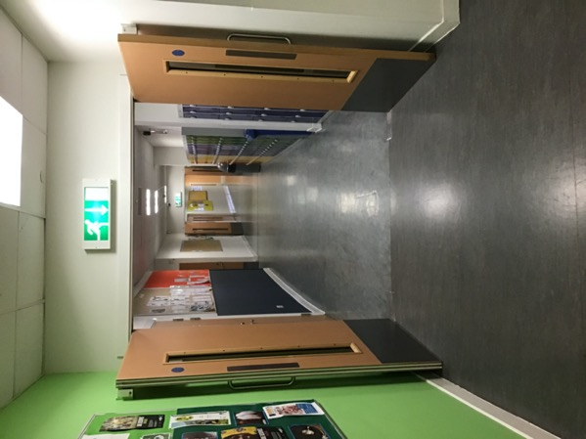
Lockers – you will have the option to hire a locker when you come to Grove. | 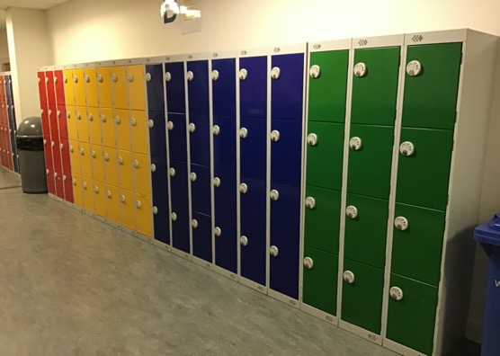
Home Economics Cooking Room - here you will be taught about food health and hygiene and cooking/baking. | 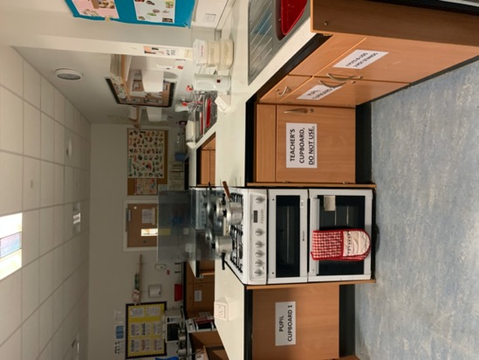
Design and Technology Workshop – here you will learn about how to safely use tools and create items from wood and metal. | 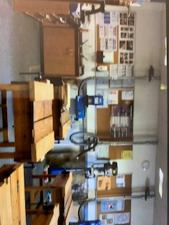
Music classroom – you will learn about music and how to play different instruments | 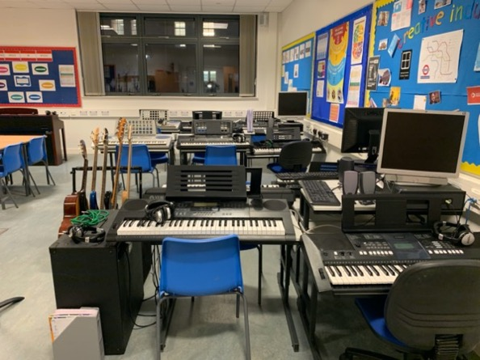
At the end of the corridor you will find the Support for Learning Base and the Pupil Support Workers’ Room. This is a good place to come if you need help or support at any time. | 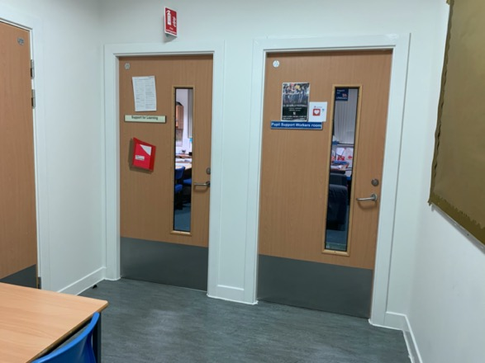

The First Floor

Area | Picture
On the First Floor we have Modern Languages, Art and Design, Maths and the Library. This picture is of a Modern Languages classroom. In First Year you will learn both French and German. | 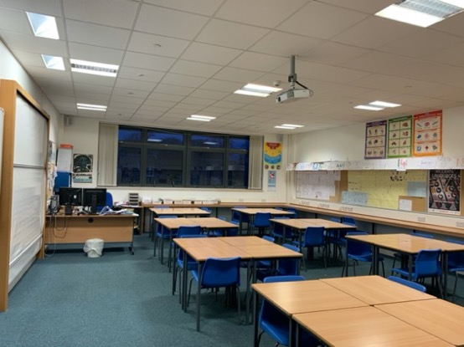
Art and Design classroom – there are always lots of interesting objects to draw or paint and lots of other pupils’ artwork on the walls to inspire you to develop your artistic and design skills. | 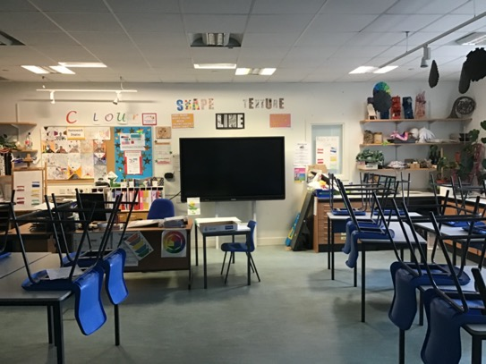
Maths classroom – you will continue to develop your number skills in both your Maths and Numeracy classes in this department. | 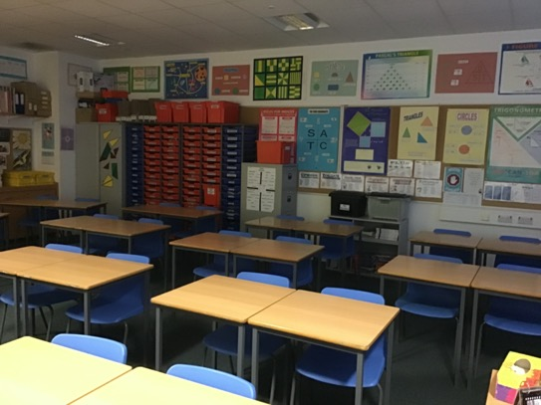
Languages corridor – you will find the English Department in this corridor where you will continue to develop your language skills and also your literacy skills. | 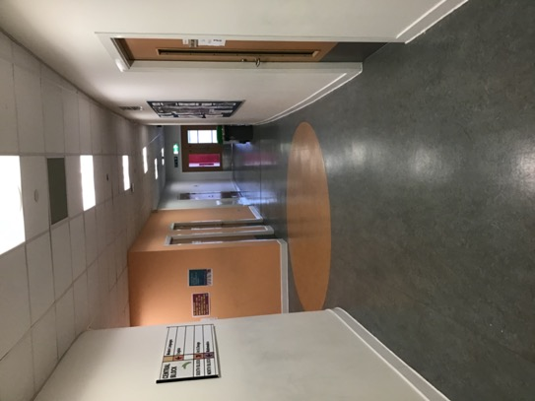
The Library – here you can choose books and read, use the computers and get involved in clubs. You will come to the Library with your classes sometimes to do research and/or type up work. You will also come to the Library for your Literacy class once a week. | 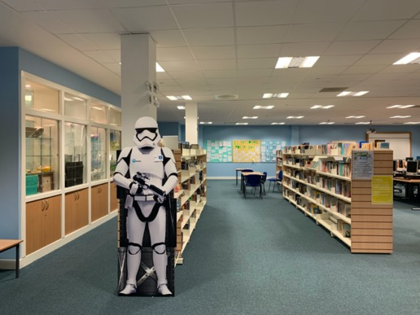
View down to the Dining Hall from the Languages Corridor. | 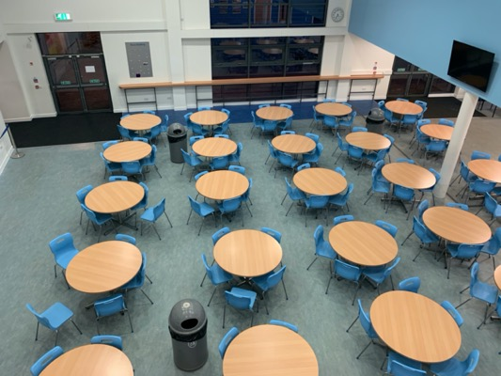

The Second Floor

Area | Picture
On the Second Floor you will find Science (Chemistry, Biology and Physics), Social Subjects (Modern Studies, Geography, RMPE and History), Computing Studies and Business Studies.  This is a picture of one of the Science Labs. In First Year you will study topics from each of the three sciences. | 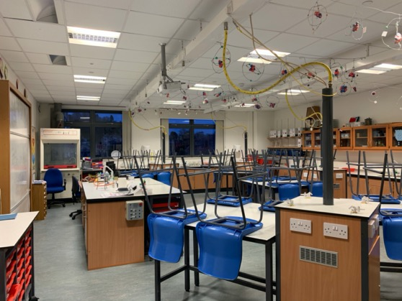
Social Studies classroom – this is one of the History rooms. You will study all four of the Social Subjects in First Year. | 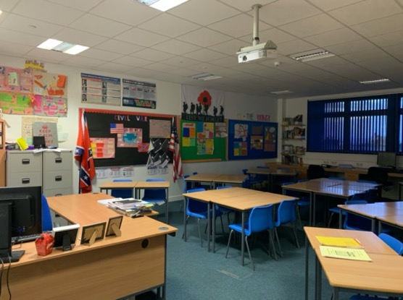
Computing Studies classroom, you will have classes in both Computing Studies and Business Studies in First Year. The layout of the rooms for both are similar, as both use computers a lot, but the subjects are very different. | 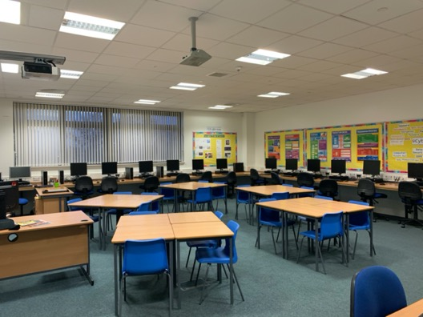

The P.E. Department

In First Year you will take part in P.E. (physical education) every week with activities on a six week rota, so there is always something new to try and new skills to learn. The different areas where you might be working are The Games Hall, The Gym, The Dance Studio, The Fitness Suite, The Swimming Pool and Dawson Park where you do your outdoor activities.  This is a picture of the Dance Studio. | 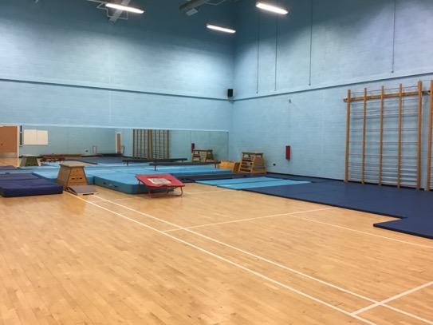
The Gym. | 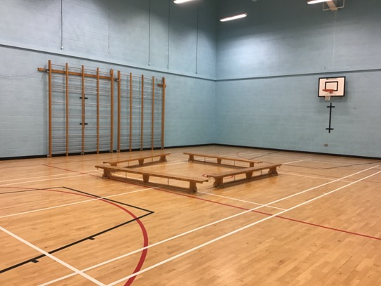
The Games Hall. | 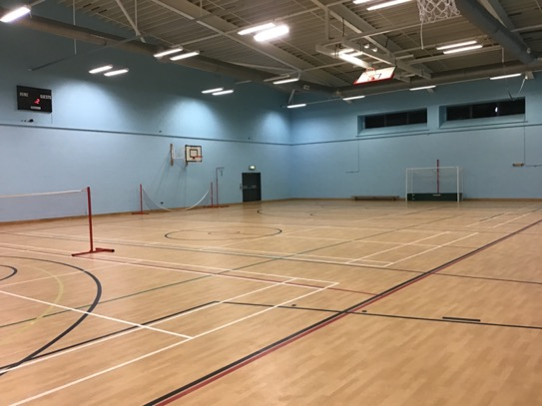

These are the Showers in the Swimming Pool changing area. | 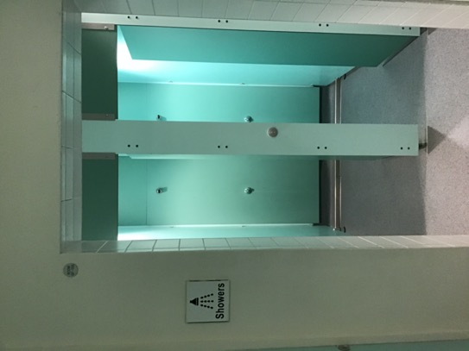
Swimming Pool – it has its cover on here to keep the heat in. | 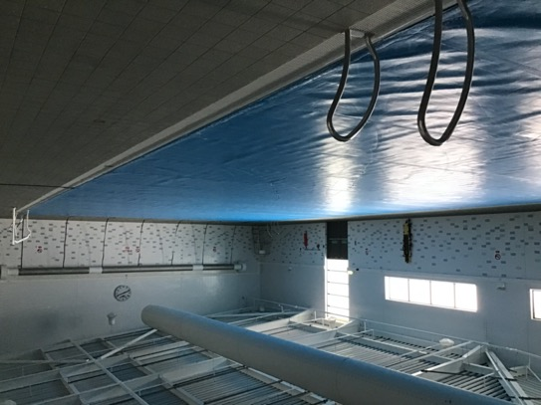
Fitness Suite – full of exercise equipment that you will be taught how to use safely. | 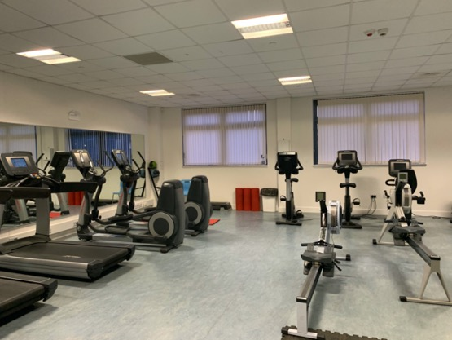

Thank you for taking the Grove Academy Photo Tour – please see the school website for more information http://grove.ea.dundeecity.sch.uk

