Help Desk Cover Tasks

- Log into telephones
- Run Import processor

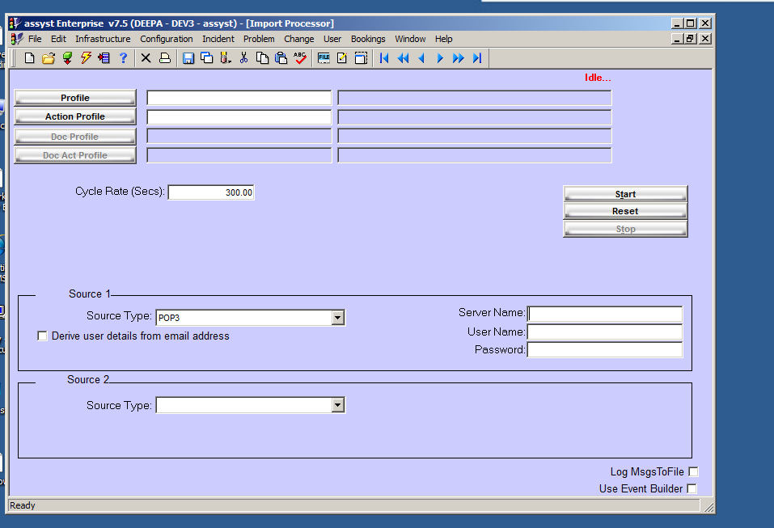

This will display all class logged in online. All these calls will be allocated to Service Desk.

Log Incident:-

Item/Service A should show the problem that the person is having eg. Active Directory; Event Recording etc.

